Project 2: Smart GenSet

Required technologies
- Things/ sensors: volt, current, temperature, level, vibration, sound, relay etc.
- Iot Hardware (Gateway): NodeMCU ESP 8266
- Communication: I2C, HTTP
- Local/ cloud server: ThingWorx
- Analytic: ThingWorx
- User interface: Mashup

Smart GenSet required
- Fuel level monitoring
- Remaining fuel available for no of hours
- Energy monitor: current, voltage, kWH
- Engine temperature and vibration monitoring
- DG set on/ off status, utilization history
- Fuel consumption per hour, per day to till date
- DG GenSet operation
- Comparative performance reports and implementation to the ThingWorx cloud server.

GenSet Parts
- Control panel
- Diesel engine
- Radiator and cooling system
- Circuit breaker
- Alternate
- Base frame and fuel tank

Level of Fuel
- In Smart GenSet we will use the fuel level measuring scenario that will measure the level of fuel.
- It will help to know the level of fuel smartly.
- As we will include many different scenarios based on the sensor with Smart GenSet
- So we will make the fuel level measuring scenario and merge it with the Smart GenSet.

Why fuel level measuring required
- Firstly we could know the fuel level
- To save the extra time consuming for checking the fuel level
- It also helps to calculate the amount of fuel.
- By this measure we can easily measure the fuel consuming time.
- We could also know how much time it would take to fill the tank.

Component for fuel level
As we are developing the Smart GenSet means we are making smart to the GenSet. We will need the following things which are;
- Thing - Ultrasonic sensor
- IoT Hardware – Arduino with Wi-Fi module, NodeMCU ESP8266
- Communication channel – Wi-Fi
- Cloud server - ThingWorx
- Dashboard – ThingWorx Academic Simulator

About all require things and sensors and their working

1. Thing – Ultrasonic Sensor

What is an Ultrasonic Sensor?
- It is used to find the distance of an object.
- It is used to find the level of water.
- It can also detect the object in the sea.
- It is used to identify the range of RADAR.

How does work ultrasonic sensor
- Transmit and receive ultrasonic wave
- Trigger pin work as a transmitter
- Echo work as a receiver
- HC-SRO4 used for work from 2cm to 400cm

How does calculate distance Ultrasonic Sensor
- One pin of the ultrasonic sensor transmits the wave.
- After collision the wave with any objects the wave reflects.
- The echo pin receives the wave frequency.
- Use the formula Time = distance / speed
- Anyone can be skipped as possible
- Then after calculate the speed of sound and time
- Then after dividing by 2 we get the distance of the object..
Example: Let distance is 10 cm then we can find the time.
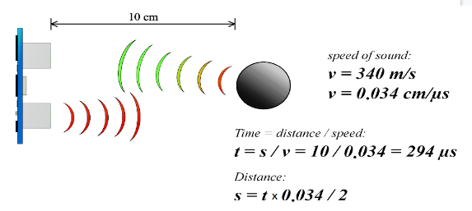

Ultrasonic Module Timing Diagram
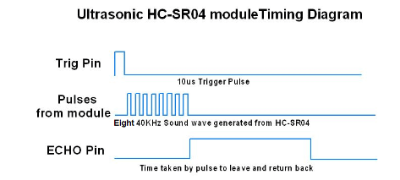

2. IoT Hardware – NodeMCU ESP8266

What is NodeMCU ESP8266?
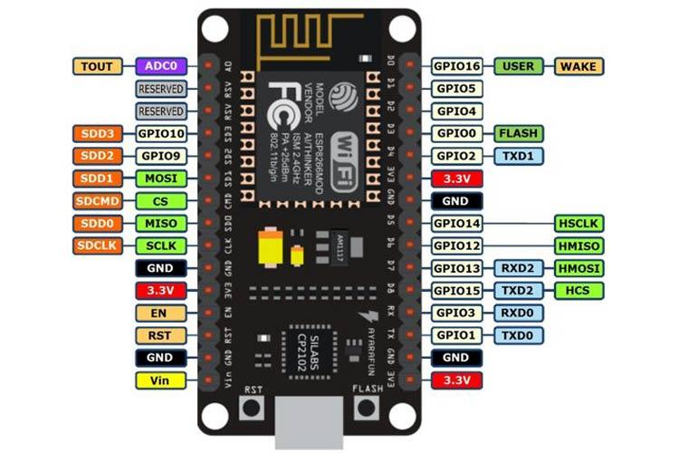
- NodeMCU is a Node MicroController Unit.
- It is an open-source firmware.
- NodeMCU is a
- Itdevelopment board specially targeted for IoT based Applications.
- It includes firmware that runs on the ESP8266 Wi-Fi SoC from Espressif Systems, and hardware which is based on the ESP-12 module.

What is NodeMCU used for?
NodeMCU is an open source platform based on ESP8266 which can connect objects and let data transfer using the Wi-Fi protocol. In addition, by providing some of the most important features of microcontrollers such as GPIO, PWM, ADC, and etc, it can solve many of the project's needs alone.

About NodeMCU board different pins and port configuration
Pin Category | Name | Description
Power | Micro-USB, 3.3V, GND, Vin | Micro-USB: NodeMCU can be powered through the USB port  3.3V: Regulated 3.3V can be supplied to this pin to power the board  GND: Ground pins  Vin: External Power Supply
Control Pins | EN, RST | The pin and the button resets the microcontroller
Analog Pin | A0 | Used to measure analog voltage in the range of 0-3.3V
GPIO Pins | GPIO1 to GPIO16 | NodeMCU has 16 general purpose input-output pins on its board
SPI Pins | SD1, CMD, SD0, CLK | NodeMCU has four pins available for SPI communication.
UART Pins | TXD0, RXD0, TXD2, RXD2 | NodeMCU has two UART interfaces, UART0 (RXD0 & TXD0) and UART1 (RXD1 & TXD1). UART1 is used to upload the firmware/program.
I2C Pins |  | NodeMCU has I2C functionality support but due to the internal functionality of these pins, you have to find which pin is I2C.

NodeMCU ESP8266 Specifications & Features
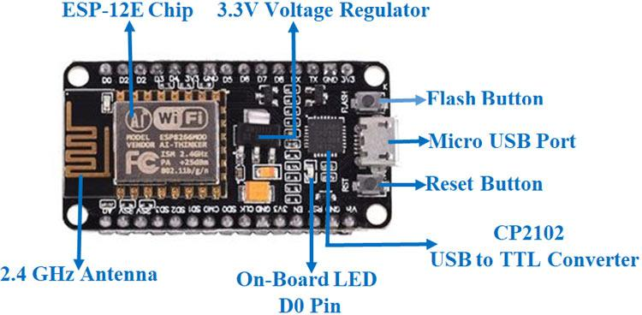

NodeMCU ESP8266 is a 32-bit

Its operating voltage is 3.3 and Input Voltage is & to 12V

It has 16 Digital I/O Pins and one Analogue I/O.

NodeMCU ESP8266 contain UARTs: 1, SPIs: 1 and I2Cs: 1

It has 4MB flash memory and SRAM: 64 KB

NodeMCU ESP8266 Clock Speed: 80 MHz
- USB-TTL based on CP2102 is included onboard, Enabling Plug n Play
- PCB Antenna
- Small Sized module to fit smartly inside your IoT projects
- ESP8266, ESP12E, ESP32
Interfacing of Ultrasonic Sensor with and NodeMCU ESP 8266
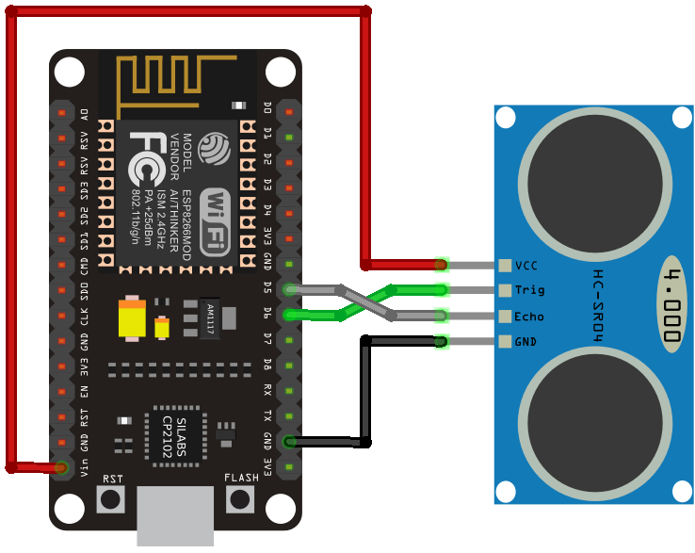

Program – Ultrasonic Sensor Interfacing to Measure Distance
const int trigPin = 12;
const int echoPin = 14;
// define sound velocity in cm/uS
#define SOUND_VELOCITY 0.034
#define CM_TO_INCH 0.393701

long duration;
float distanceCm;
float distanceInch;

void setup()
{
// Starts the serial communication
Serial.begin(115200);
// Sets the trigPin as an Output
pinMode(trigPin, OUTPUT);
// Sets the echoPin as an Input
pinMode(echoPin, INPUT);
}

void loop()
{
// Clears the trigPin
digitalWrite(trigPin, LOW);
delayMicroseconds(2);
// Sets the trigPin on HIGH state for 10 micro seconds
digitalWrite(trigPin, HIGH);
delayMicroseconds(10);
digitalWrite(trigPin, LOW);

// Reads the echoPin, returns the sound wave travel time in microseconds
duration = pulseIn(echoPin, HIGH);

// Calculate the distance
distanceCm = duration * SOUND_VELOCITY / 2;

// Convert to inches
distanceInch = distanceCm * CM_TO_INCH;

// Prints the distance on the Serial Monitor
Serial.print("Distance (cm): ");
Serial.println(distanceCm);
Serial.print("Distance (inch): ");
Serial.println(distanceInch);

delay(1000);
}

Applications
- Prototyping of IoT devices
- Low power battery operated applications
- Network projects
- Projects requiring multiple I/O interfaces with Wi-Fi and Bluetooth functionalities

3. Communication channel – warless communication protocol
Different types of communication protocol for the sensors and IoT Hardware

4. Cloud server – ThingWorx

What is ThingWorx?
- ThingWorx is end-to-end technology platform.
- It is designed for the industrial Internet of Things (IIoT).
- ThingWorx enable to manage the development lifecycle for IoT Application.
- It provides many types of features to manage the IoT devices.
- It helps to develop and deploy of smart, connected devices rapidly

How to login into ThingWorx?
Step 1: Goto your server IP Address and Enter provided User ID and Password

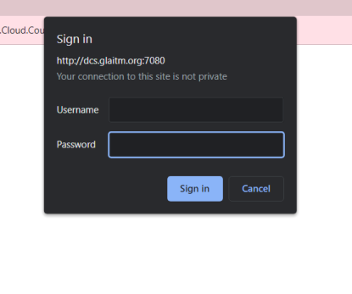
Step 2: After login successfully your interface will be as following 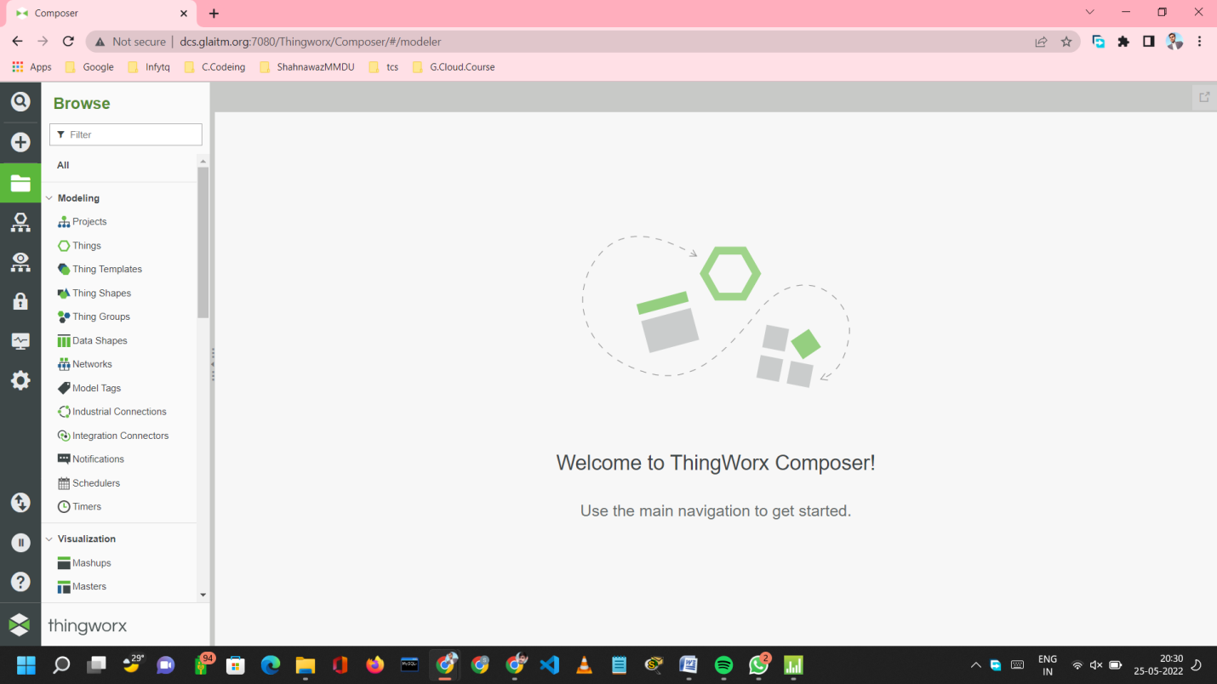

How to create a Project in ThinWorx?
Step 1: Click on “Browse” icon then on “Projects” from Modelling section then click on “New” to create new Project.

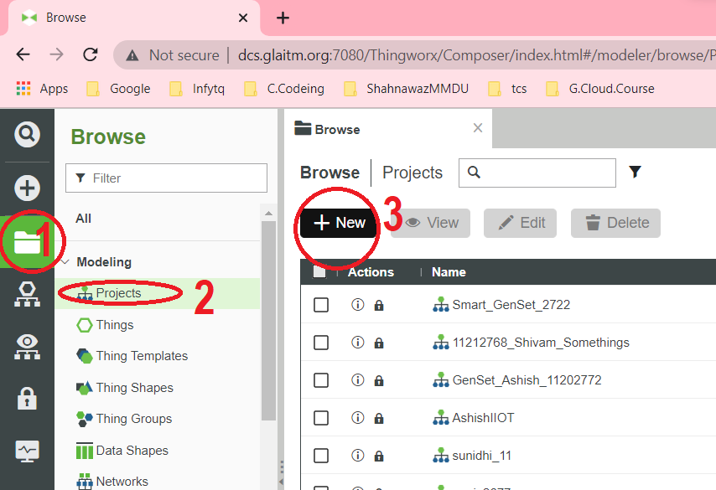

Step 2: Then enter the following things
- Project name
- Project description (optional)
- Then click on Save

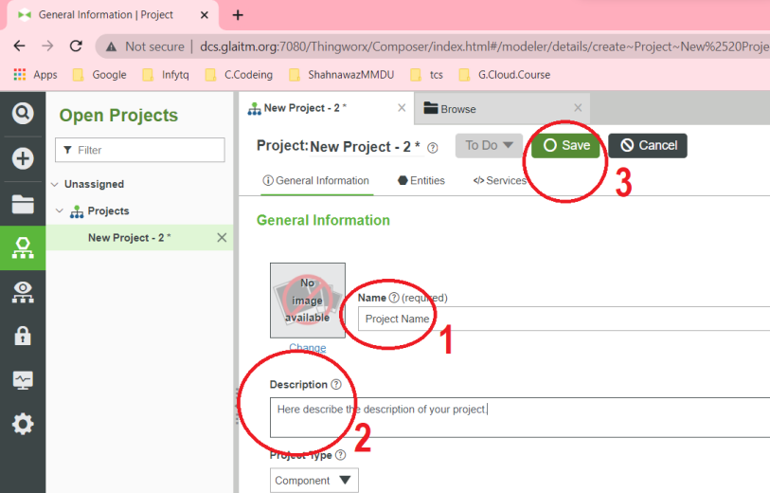

How to create ‘Things’ in ThingWorx?
Step 1: Click on “Browse” icon then on “Things” from Modelling section then click on “New”

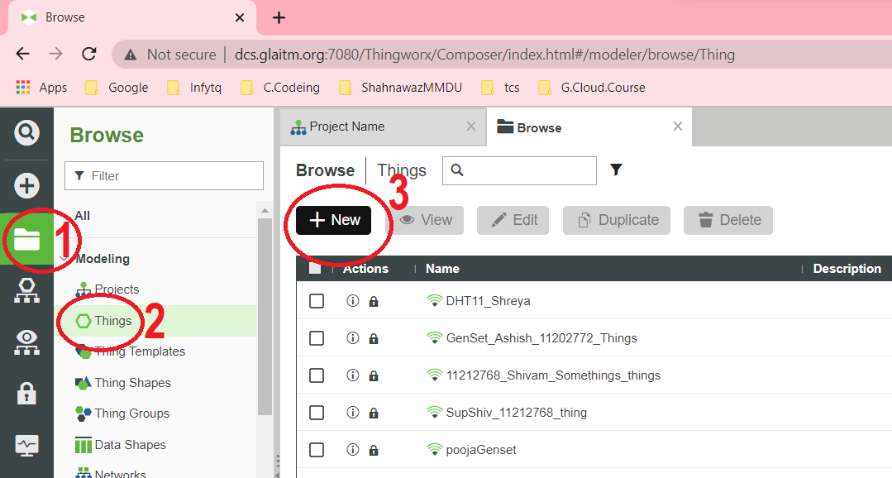

Step 2: Enter the following things
- Enter things name
- Enter things description (optional)
- Enter Project name (if you have created) or Select PTCDefaultProject
- Select RemoreThing and scroll down
- Mark on ‘publish’
- Click on save

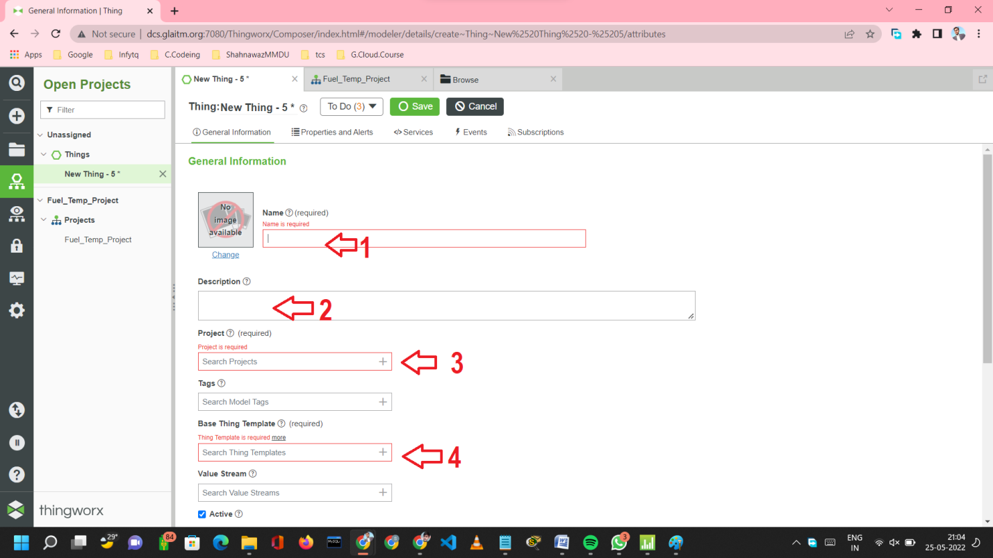

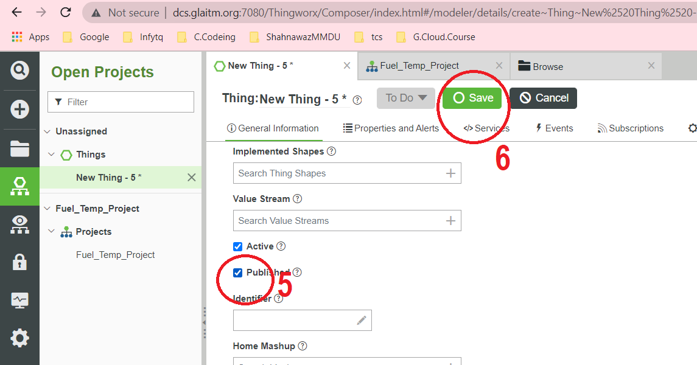
Adding two different things (Fuel Level & Engine Temperature) in ‘Things’.
Step 1: Click on ‘Properties and alerts’
Step 2: Click on ‘Add’ and select ‘Direct’
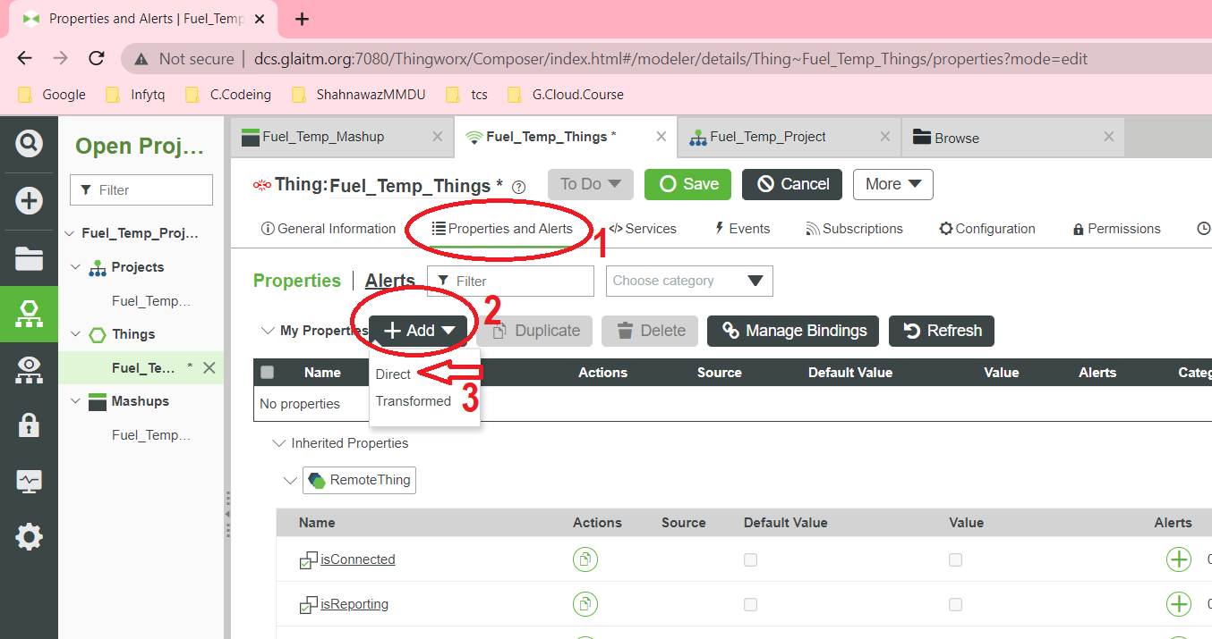
Step 3: Adding ‘Property’
- Enter property name
- Give description (optional)
- Select base type (Number)
- Click on or for save add one more property (you may also follow from the beginning to add different properties.
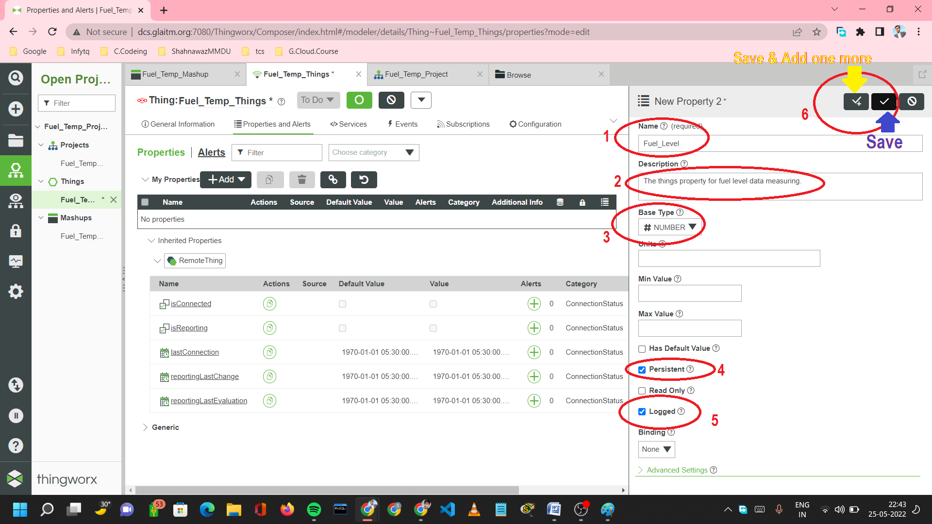
Step 4: After added the different property click on the save.
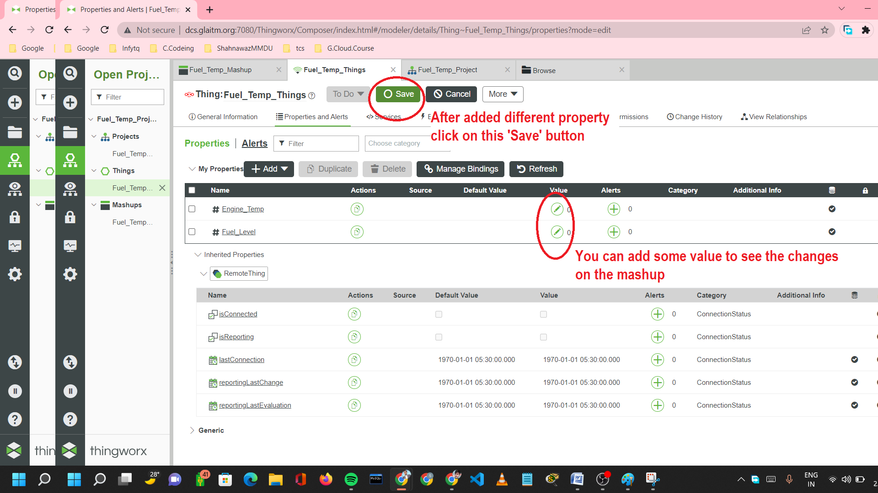

How to create a ‘Mashup’ in ThingWorx?
Step 1: Click on “Brows” icon then on “Mashup” from Visualization section then click on “New”
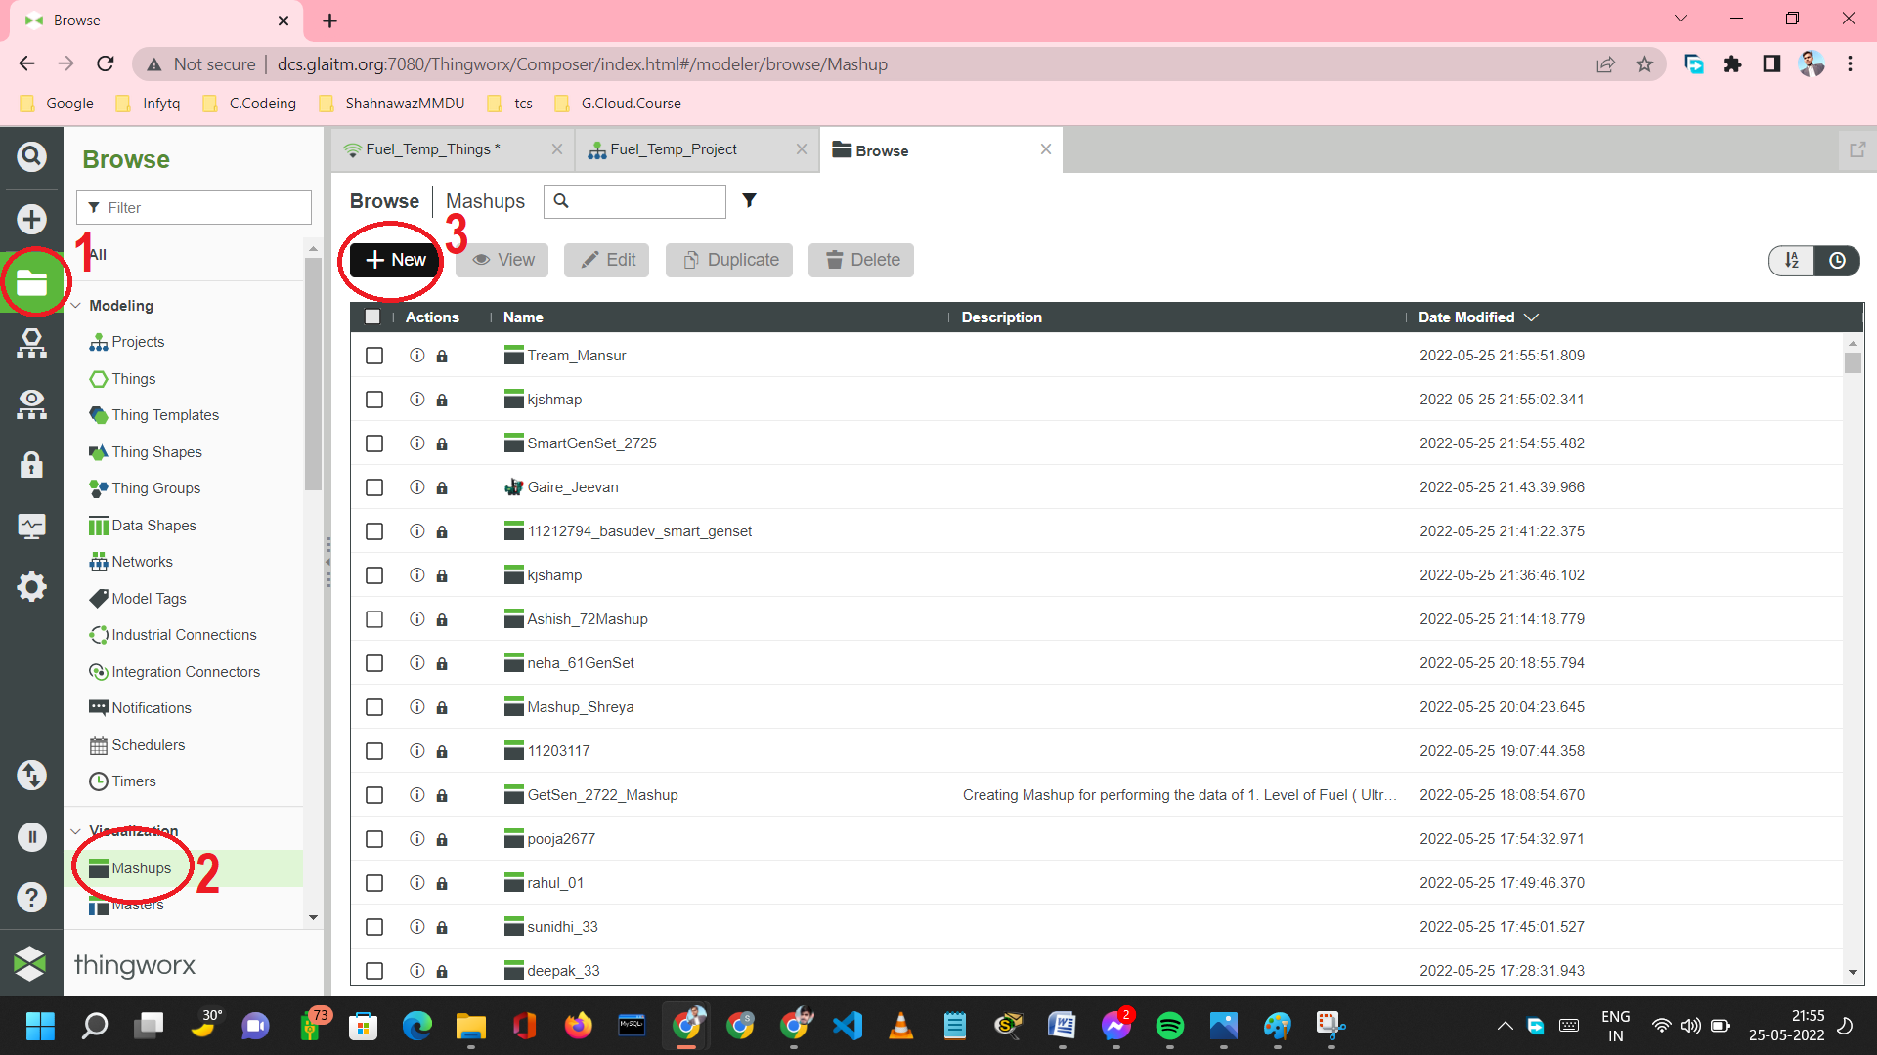
Step 2: Click on ‘Responsive’ or any other preferred Mashup then click on ok.
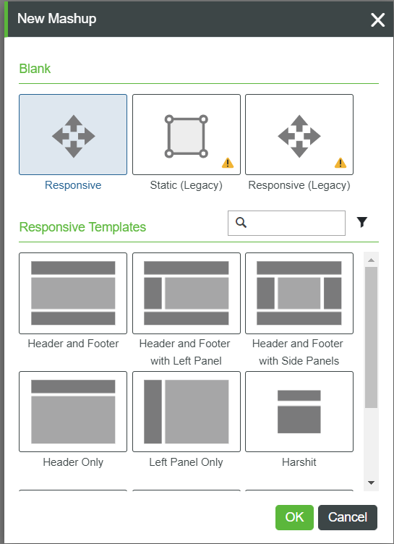

Step 3: After select ‘Responsive’ and clicked on ok, Enter the following things
- Enter Mashup name
- Enter your created project name or Select ‘PTCDefaultProject’
- Click on ‘Save’
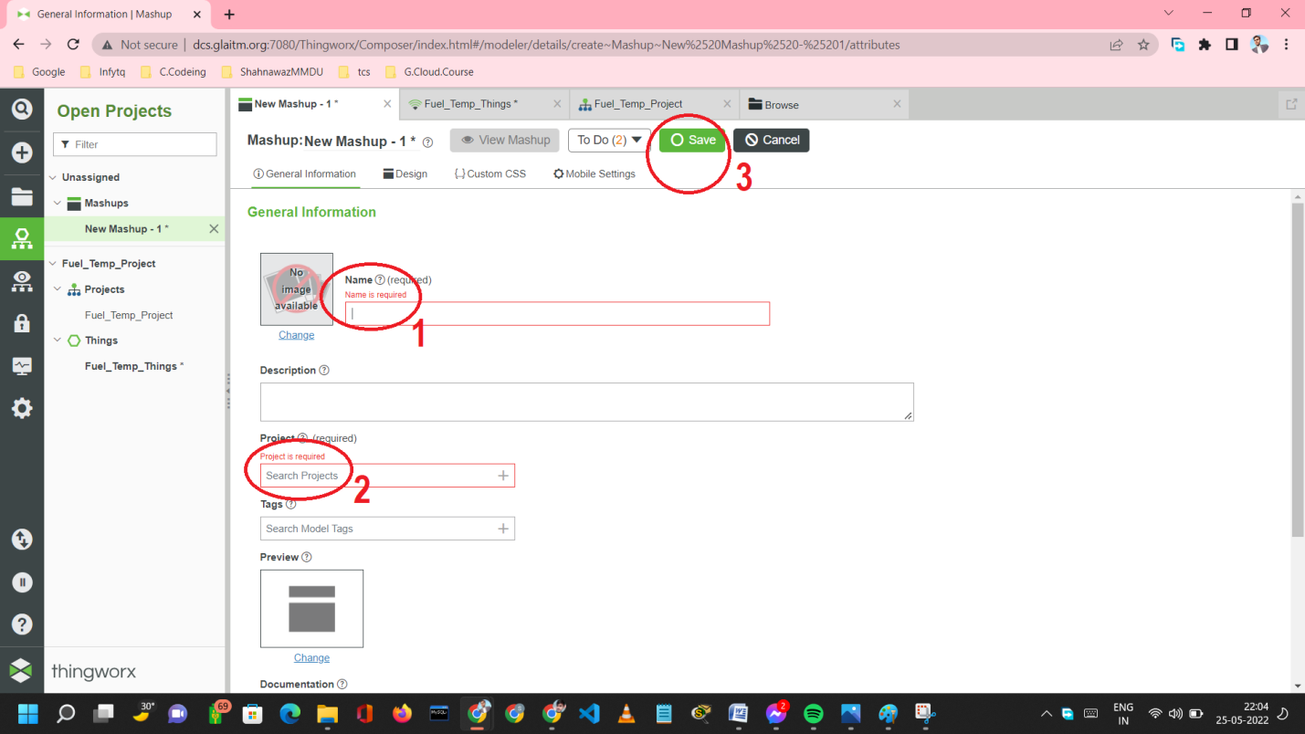
Step 4: After save Mashup follow given things to drag required widget at workspace in Mashup
- Click on Design
- Click on Widget
- Choose category all then search you required widgets
- Then drag the widgets at the workspace
- Here we will add Gauge, LED and Auto Refresh button
- After dragged all required widgets we will bind the data of different property of Things with widgets.
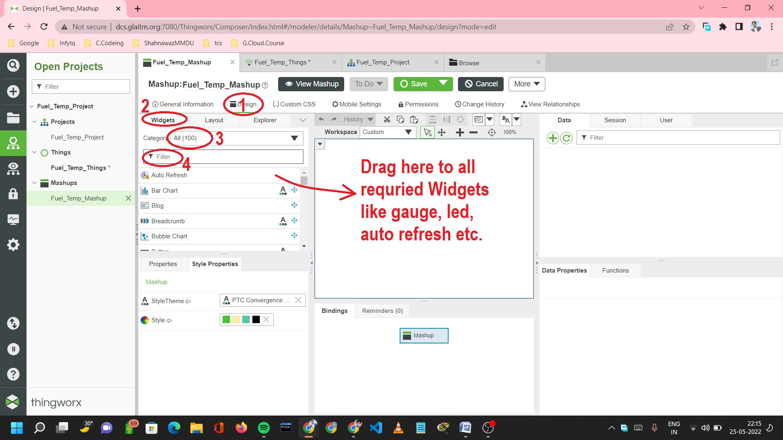
Widgets positioning (static) and Label name
- To move widgets anywhere Choose widgets Click on Layout and Choose Static
- To grieve legend name Choose widgets Click on Properties Enter Legend Name
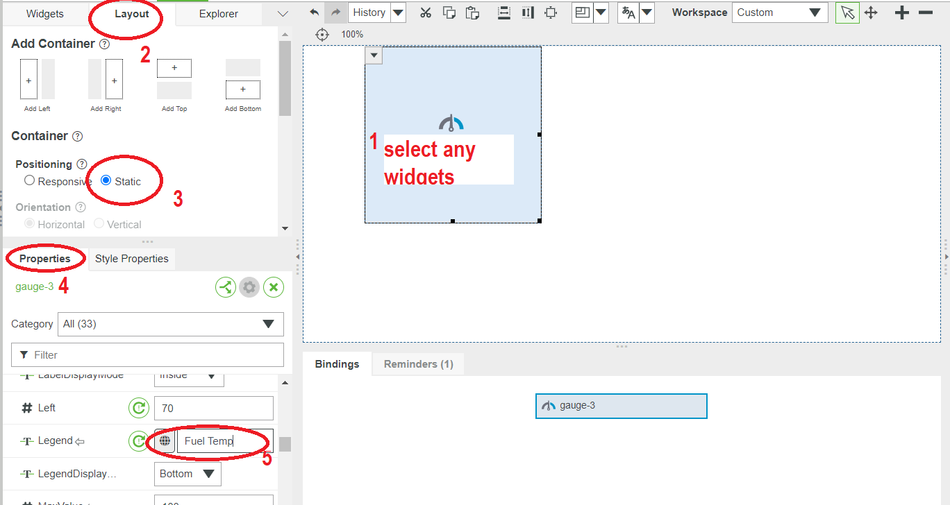

All the required widgets added into Mashup as workspace
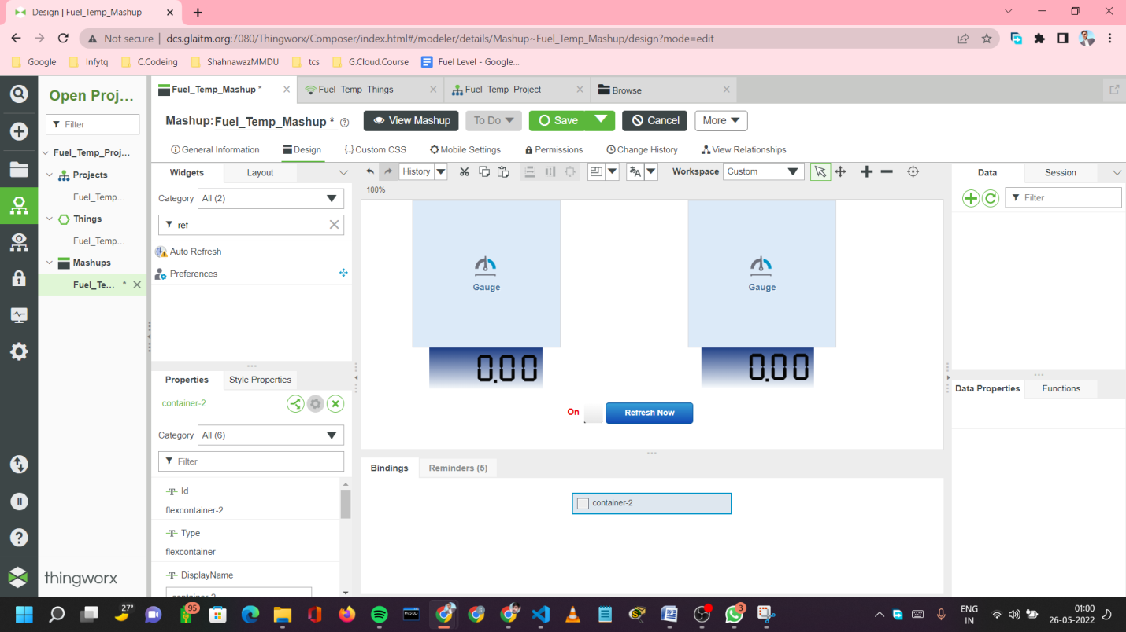

How to bind the data of different properties of Things with widgets?
Step 1: Click on  icon from Data section of Mashup
Step 2: Choose ‘Things’ from Entity Type box
Step 3: Choose your create Things name from Entity box
Step 4: Choose ‘Properties’ from Select Service Category box
Step 5: Choose ‘GetProperties’ from Service box and click on arrow
Step 6: Mark on ‘Execute on Load’ from ‘Selected Services’ area then click on ok.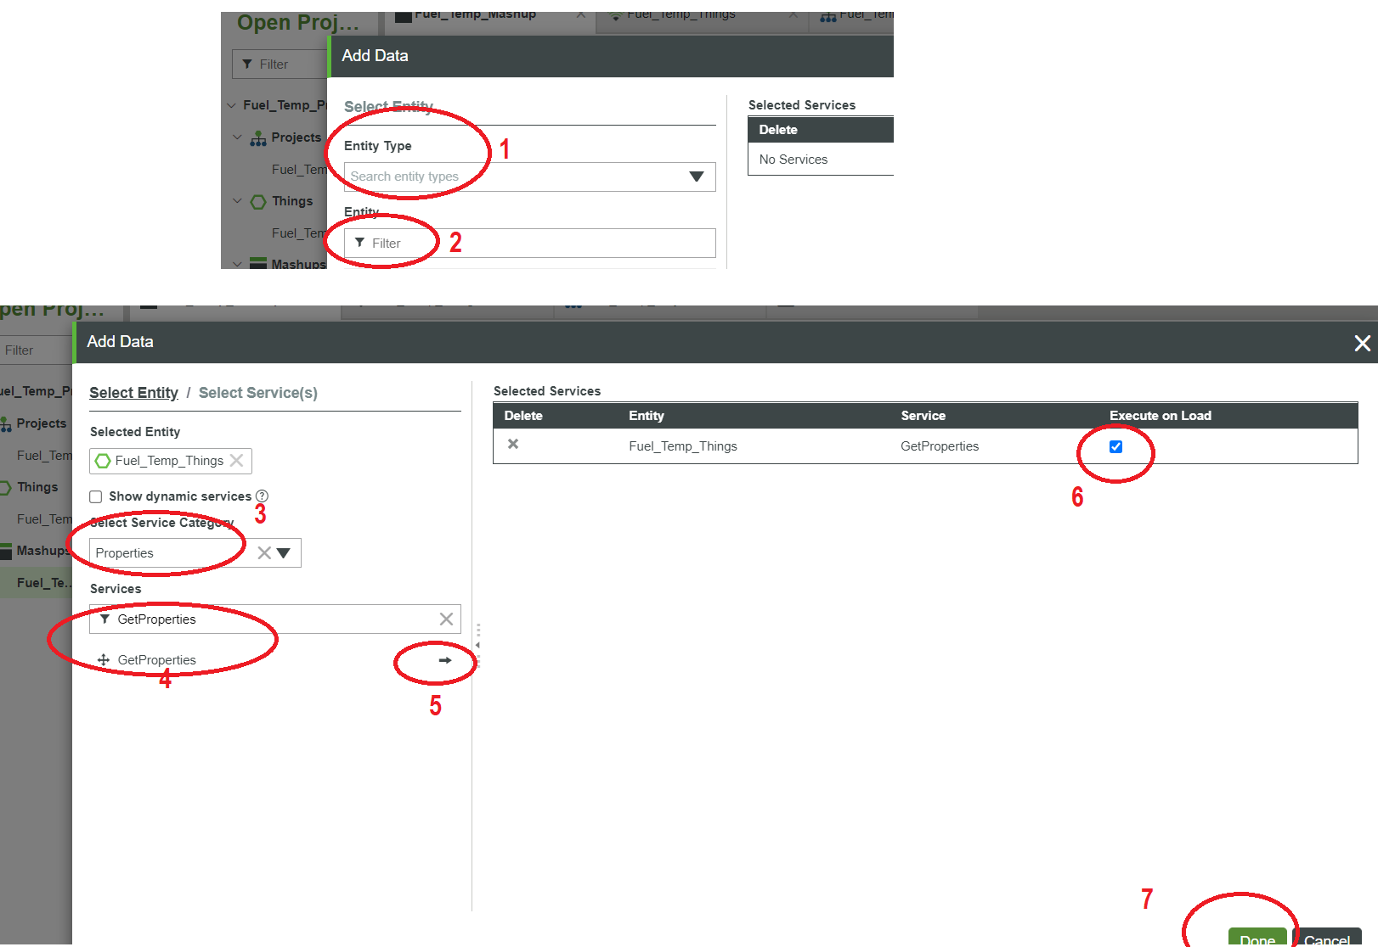

Step 7: After get the different properties in data section
- Drag the Fuel_Level property to the Fuel_ Level Gauge widgets and select Data option
- Drag the Fuel_Level property to the Fuel_ Level LED widgets and select Data option
- Drag the Engine_Temp property to the Engine_Temp Gauge widgets and select Data option
- Drag the Engine_Temp property to the Engine_Temp LED widgets and select Data option

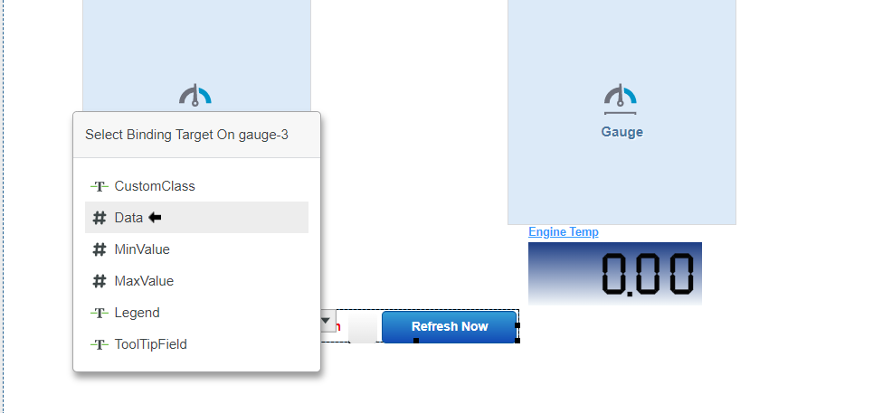

How to use Auto Refresh button
Step 1: Click on Arrow mark on the Auto Refresh Button
After performed all previous steps created things, Mashup, different properties and binded the properties their corresponding widgets.
We will use a simulator to handle its all activity with Hardware.
Connect with simulator
Url : dcs.glaitm.org
Api key :1f28ee11-c7ed-4d3f-b5a1-4e28241dc6f4
Port no : 7080

5. Dashboard – ThingWorx Academic Simulator

The ThingWorx Academic is a simulator
It helps to handle the activity neat and clean workspace
It helps to connect the hardware and Mashup easily
It is very easy to use to apply the operations

How to connect ThingWorx to ThingWorx Academic Simulator
Step 1: Click on Browser icon then Application Key and then on New Icon
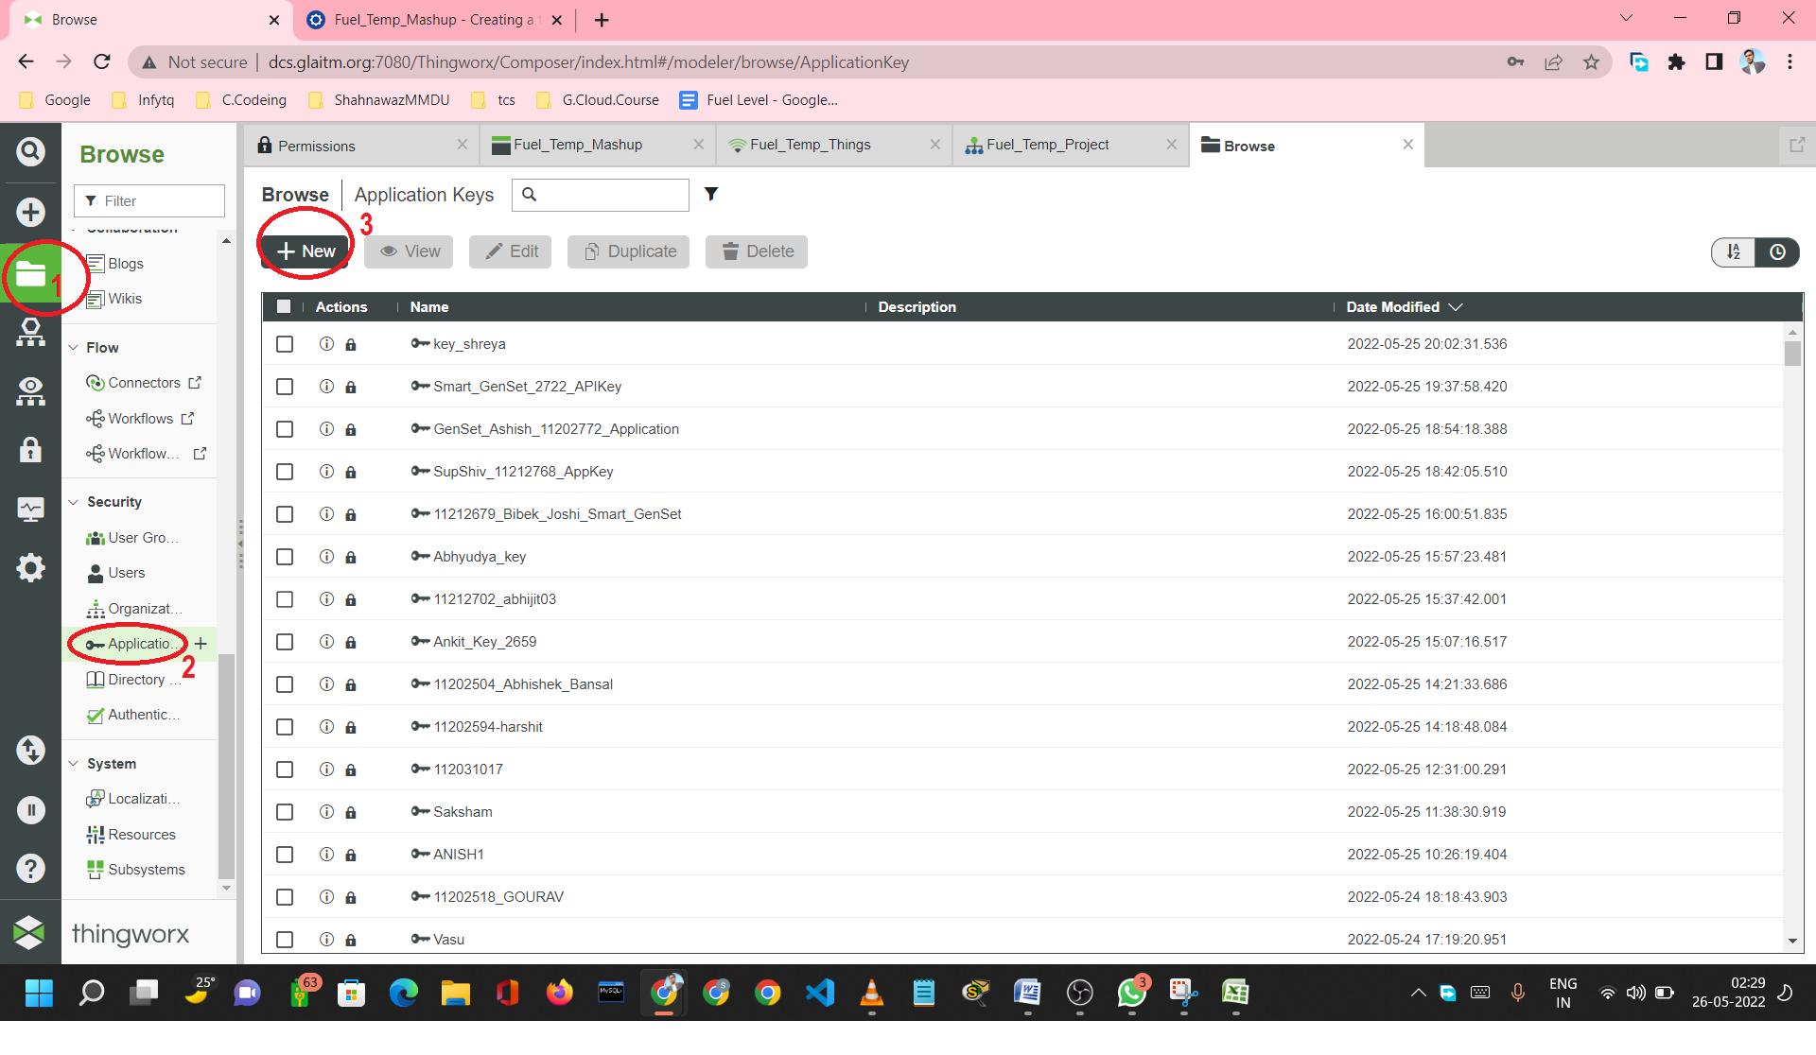
Step 2: Enter the following things
- Enter API Key name
- Select your project if you have creade of choose PTCDefaulProject
- Choose you login user id
- Scroll Down and choose your API Link Expire date
- Then click on Save
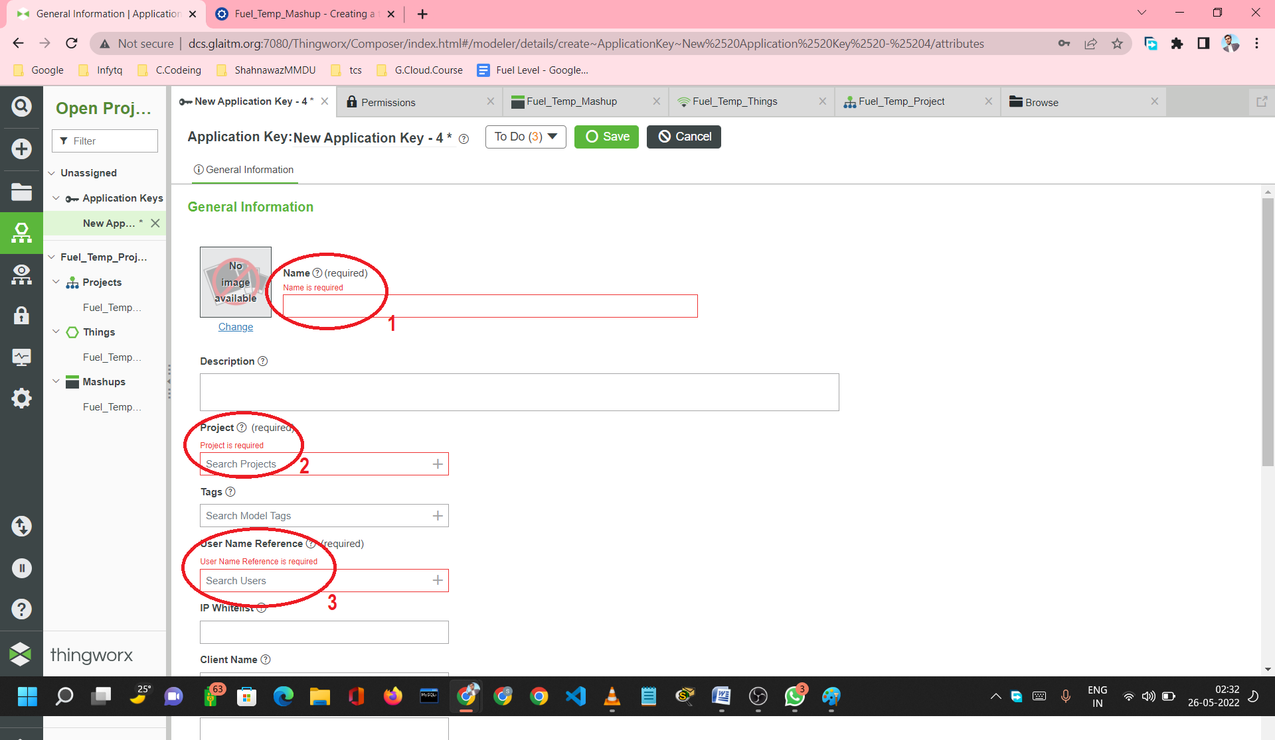

Step 3: After click on the save button an API Key will be visible just about the Expiry date, c
Step 4: Copy that API Key

ThingWorx Academic Simulator
Step 5: Open ThingWorx Academic Simulator
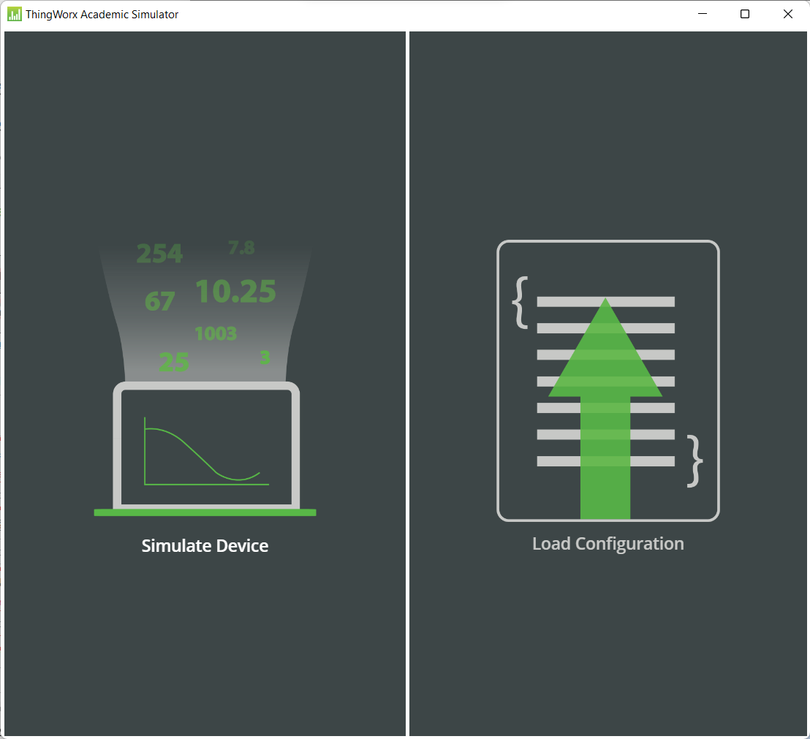

Step 6: Click on Simulate Device

Step 7: Enter server info
- Server URL : only the main url except to https:// and after domain naime
- Application Key: The generate API Key
- Port : Server port number
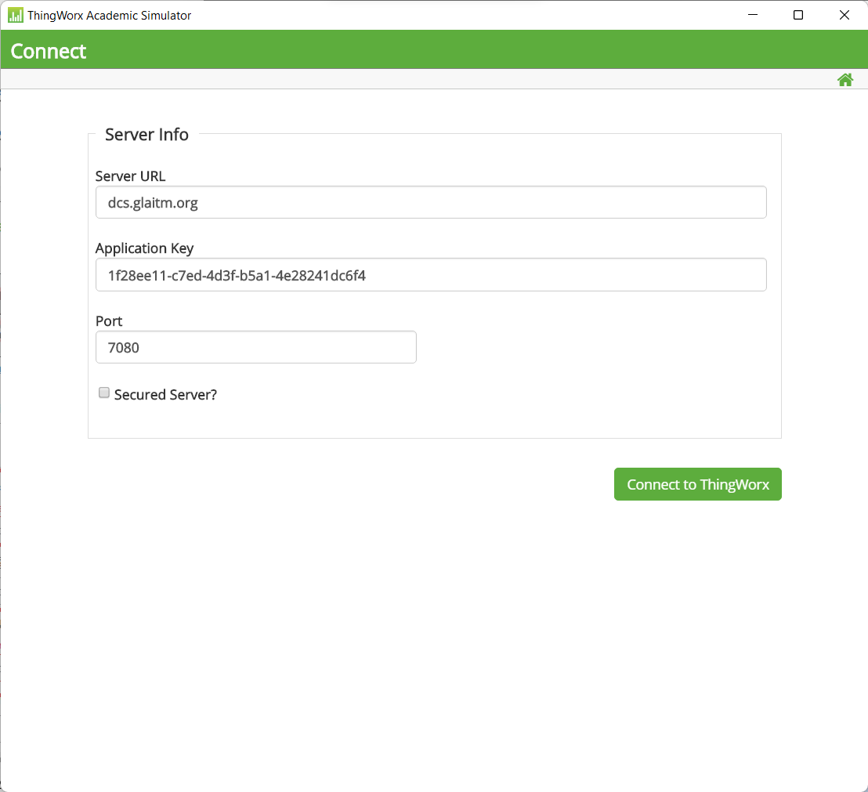

Step 8: After clicked on ‘Connect to ThinkWorx’ you will see the following interface
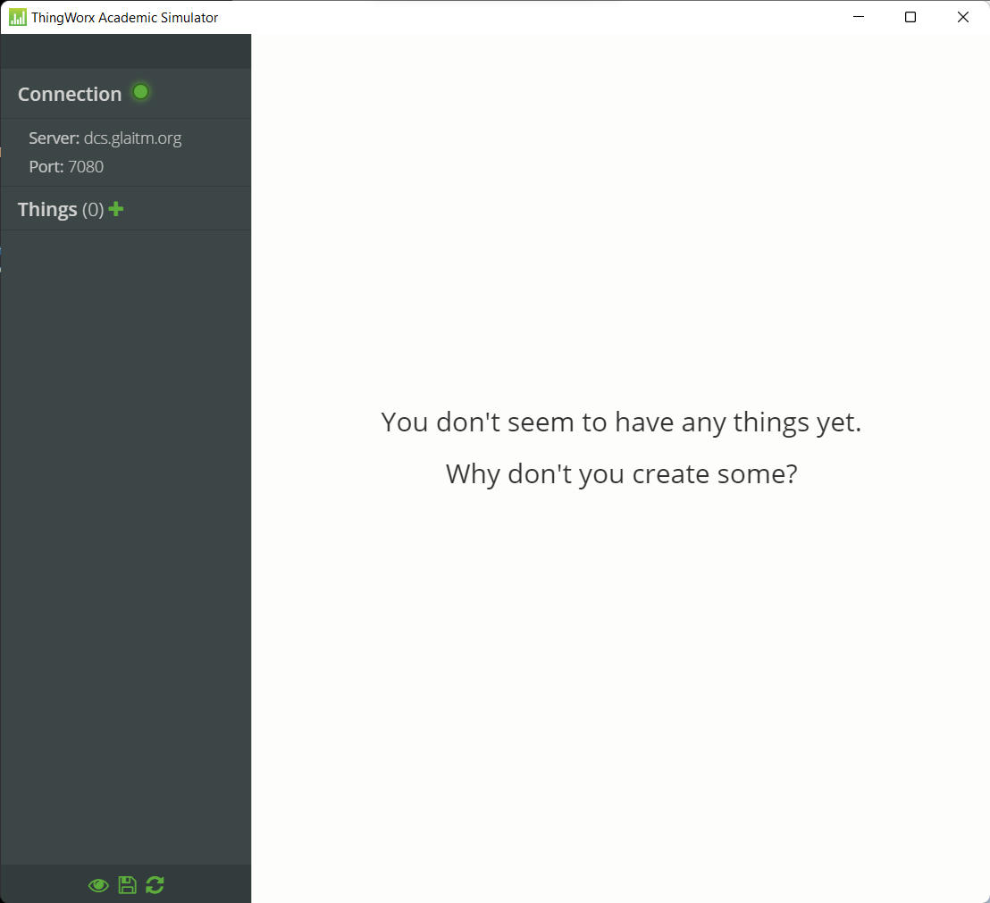

Step 9: Add things to click on Things (0) + Icon
- Enter you Things name in the box then click on Right arrow
- If Things not show in Platform then ‘Enter your created Things name’ in ‘Add new remote Thing’ and click on ‘Add New Thing’
- A new Things will be show in the ‘Selected Things’ area
- Then click on Connect Things button

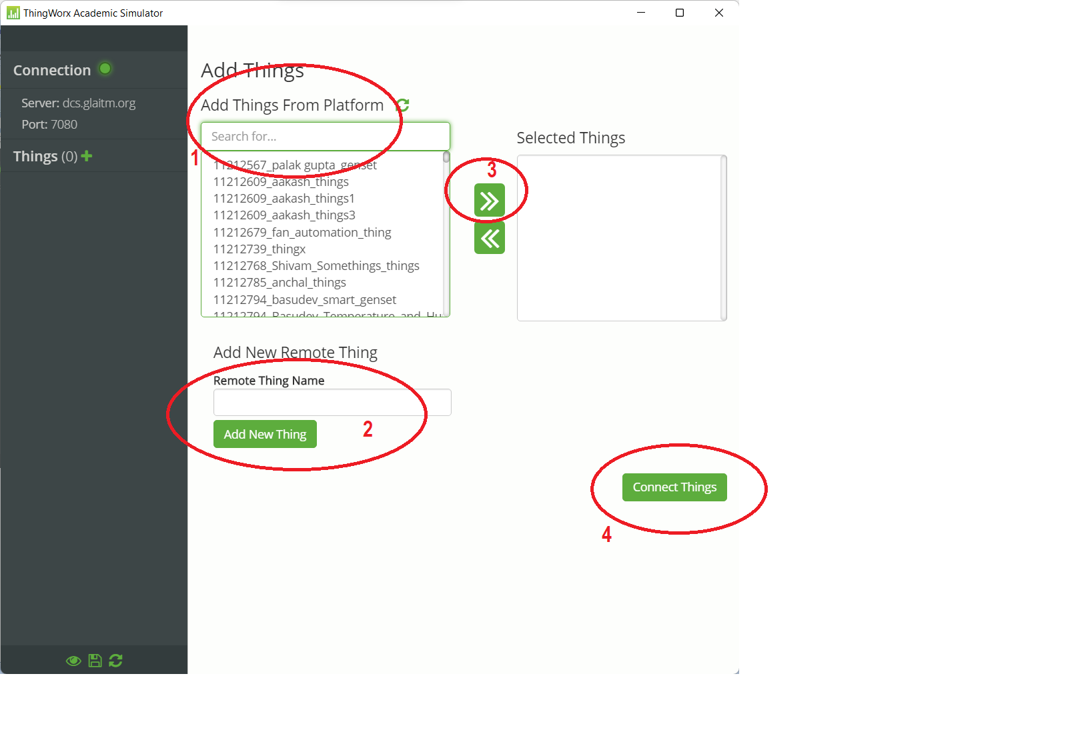

Step 10: Now you will see the different properties list of Things
This configuration file you can save from left button save icon or you can see the Things property data.
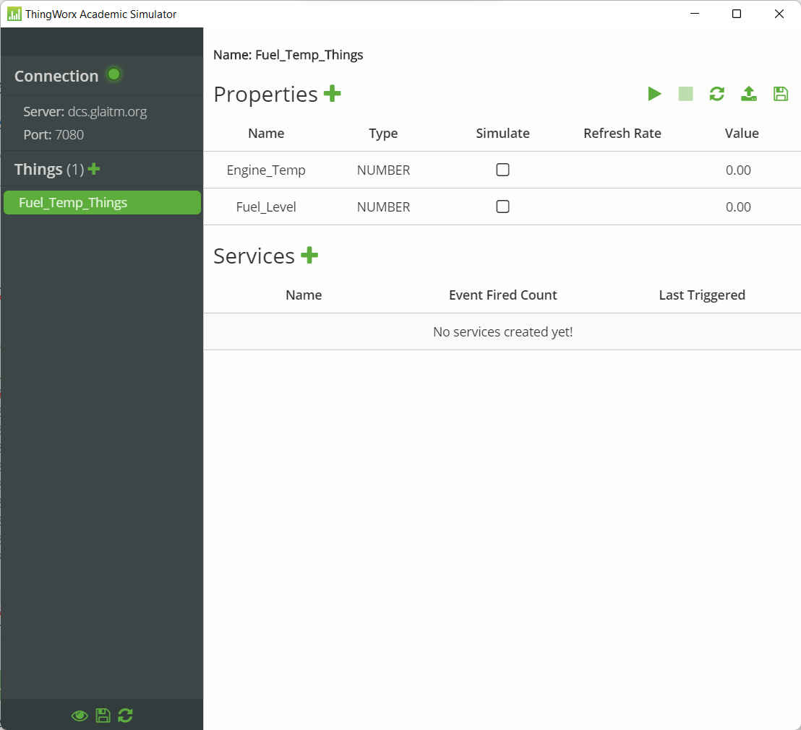

Now we connect the hardware to put the verified code in this simulator visualize the the function and update

